INFORMATION SHARING AGREEMENT

[Perth and Kinross PCIP Federation]
[PCIP eHealth Programme]
[April 2020]

Contents
Introduction 4
1 Parties, Scope and Purpose 5
1.1 Name and details of the parties who agree to share information 5
1.2 Business and legislative drivers for sharing data. 5
1.2.1 Purpose(s) of the information sharing 5
1.2.2 Legal basis for the processing and constraints 6
2 Description of the information to be shared 7
3 Description and manner of information sharing 8
3.1 Data flows 8
3.2 How data/information is to be accessed, processed and used 8
3.3 Summary of how decisions are going to be made with regards to the manner of the processing. 8
4 Impact assessments and preparatory work 9
5 Privacy information (transparency requirement) 10
6 Accuracy of the information 11
7 Data retention and secure disposal 12
8 The rights of individuals 13
8.1 Subject access request, FOI and data portability. 13
8.2 Objection or restriction to processing, rectification and erasure. 13
8.3 Rights related to automated decision making, including profiling. 13
8.4 Direct Marketing 14
9 Security, risk and impact of the processing 16
9.1 Agreed standards, codes of conduct and certifications 17
10 International transfers of personal data 18
10.1 List of countries where the data will be transferred to (if applicable). 18
10.2 Reasons for transferring personal data outside the UK. 18
11 Implementation of the information sharing agreement 20
11.1 Dates when information sharing commences/ends 20
11.2 Training and communications 20
11.3 Information sharing instructions and security controls 20
11.4 Non-routine information sharing and exceptional circumstances 20
11.5 Monitoring, review and continuous improvement 21
12 Sign-off 23
13 Appendix 1: List of Work instructions, policies and procedures 26
14 Appendix 2: Data items and adequacy 27

Introduction
To support the New GP Contract and Primary Care Improvement Plan (PCIP).
A Test of Change was undertaken to test the suitability of a Shared Practice Access (federated) model to support PCIP and the new GMS contract areas.
Using Vision Anywhere, Shared Access and Shared Appointments in order to enable visibility of and access to data across practices in Dundee.
Following evaluation of the Test of Change the GMS Contract Implementation Advisory Group has approved implementing across Tayside as business as usual.

Parties, Scope and Purpose

Name and details of the parties who agree to share information

Legal name of parties subject to the ISA and Head Office address | Short name of the party | Role in this agreement :  Data Controller or Data Processor (*) | ICO Registration
NHS Tayside Board  Ninewells Hospital and Medical School  Dundee  DD1 9SY | NHS Tayside | Data Controller | Z8537226
Carse Medical Practice  The Rowans  High Street  Errol  PH2 7QJ |  | Data Controller | ZA067213
Kings Practice  Glover Street Medical Centre  133 Glover Street  Perth  PH2 0JB |  | Data Controller | Z5057626
The Mauve Practice  Drumhar Health Centre  South Methven Street  Perth  PH1 5PD |  | Data Controller | Z109435X
Orwell Practice  Loch Leven Health Centre  Muirs  Kinross  KY13 8FP |  | Data Controller | Z7095459
Perth City Medical Centre  Caledonian Road  Perth  PH2 8HH |  | Data Controller | Z732193X
St Serfs Practice  Loch Leven Health Centre  Muirs  Kinross  KY13 8FP |  | Data Controller | Z7095476
Taymount Surgery  1 Taymount Terrace  Perth  PH1 1NU |  | Data Controller | Z6375861
Victoria Practice  Glover Street Medical Centre  133 Glover Street  Perth  PH2 0JB |  | Data Controller | Z486463X
Whitefriars Green Medical Practice  Whitefriars Street  Perth  PH1 1PP |  | Data Controller | Z5038615
Whitefriars Red Medical Practice  Whitefriars Street  Perth  PH1 1PP |  | Data Controller | Z5746122
The Yellow Practice  Drumhar Health Centre  South Methven Street  Perth  PH1 5PD |  | Data Controller | Z650406X
Aberfeldy Medical Practice  Taybridge Road  Aberfeldy  PH15 2BL |  | Data Controller | Z8159694
Alyth Health Centre  New Alyth Rd  Alyth  Blairgowrie  PH11 8EQ |  | Data Controller | Z4912404
Ardblair Medical Centre  Ann Street  Blairgowrie  PH10 6EF |  | Data Controller | Z6416835
Atholl Medical Centre  Ferry Road  Pitlochry  PH16 5FG |  | Data Controller | Z627518X
Comrie Medical Centre  Strowan Road  Comrie  PH6 2LW |  | Data Controller | Z5589224
Coupar Angus Medical Centre  Candlehouse Lane  Coupar Angus  PH13 9DD |  | Data Controller | ZA226654
Craigvinean Surgery  Dunkeld  Perthshire  PH8 0AD |  | Data Controller | Z6909677
Crieff Health Centre – Blue Practice  Kings Street  Crieff  PH7 3SA |  | Data Controller | Z7572303
Crieff Health Centre – Red Practice  Crieff Medical Centre  Kings Street  Crieff  PH7 3SA |  | Data Controller | Z7005894
St Margarets Health Centre  St Margarets Drive  Auchterarder  PH3 1JH |  | Data Controller | Z5609251
Stanley Medical Centre  43 Shielhill Place  Stanley  Perth  PH1 4NN |  | Data Controller | Z4859704
Strathmore Surgery  Jessie Street  Blairgowrie  PH10 6BT |  | Data Controller | Z104939X
(*) for Data Processor, please identify on behalf of what data controller(s)

1.2 Business and legislative drivers for sharing data.
To support new GMS Contract 2018 and Primary Care Improvement Plans. This work was undertaken as a test of change but has now been adopted as business as usual.

1.2.1 Purpose(s) of the information sharing

To support 2018 Scottish GMS Contract and Tayside Primary Care Improvement Plan.

To allow NHST staff, visiting healthcare professionals and 3rd parties working on behalf of NHS Tayside and/or the practice to be able to access the GP appointments system and patient records in order to provide and inform appropriate care. To provide safe effective use of patient data as the multi disciplinary team grows and services are re-designed.

Some of the staff are currently able to do this but only by attending the Practice

Staff from the following services will be provided with read/write access to a federated version of the GP clinical system.
NHS Tayside Services
- Community Treatment and Care
- First Contact Physiotherapy/MSK
- Pharmacotherapy
- Urgent Care
- Community Link Worker
- Community Mental Health
- Vaccination Transformation Programme
- Secondary Care – appointment booking functionality. Booking a patient directly in for phlebotomy within their practice area, with the results going back to referring secondary care clinician for action.

A test of change with some of the above services was undertaken with rollout to all services after the test period.

In addition the federated version of the GP clinical system could be used to support throughout Covid19.

Indicate how the data controllers will decide upon changes in the purpose(s) of the information sharing | Jointly or independently
 | Jointly
Instructions for reaching agreement on any changes to purpose of the sharing are listed in the table in Appendix 1, called; List of Work instructions, policies and procedures.

1.2.2 Legal basis for the processing and constraints
Without detriment of any other legal basis that may be applicable (e.g. criminal investigation, etc.) the following are the core legal basis for each of the parties to process the data in this agreement:
Data Protection Principles
The Parties have entered this Agreement to assist them with processing personal data in accordance with the data processing principles. Those principles are, in summary:
Personal data shall be:
(a) processed lawfully, fairly and in a transparent manner
(b) collected for specified, explicit and legitimate purposes
(c) adequate, relevant and limited to what is necessary
(d) accurate and, where necessary, kept up to date
(e) kept in a form which permits identification of data subjects for no longer than is necessary for the purposes for which the personal data are processed
(f) processed in a manner that ensures appropriate security of the personal data,
Accountability is central to General Data Protection Regulation: controllers are responsible for compliance with the principles and must be able to demonstrate this to data subjects and the regulator.
Constraints to Processing
As well as having to adhere to Data Protection principles, NHS Scotland also needs to take into consideration Caldicott Principles and the common law duty of confidentiality which can constrain what information can be shared and with whom. The personal data is shared to support the provision of health care treatment.

Caldicott Principles
The Parties acknowledge that the Caldicott Principles must be applied to the processing of personal data to ensure that the information is only shared for justified purposes.
Principle 1 - Justify the purpose(s) for using confidential information
Principle 2 - Only use it when absolutely necessary
Principle 3 - Use the minimum that is required
Principle 4 - Access should be on a strict need-to-know basis
Principle 5 - Everyone must understand his or her responsibilities
Principle 6 - Understand and comply with the law
Principle 7 - The duty to share information can be as important as the duty to protect patient confidentiality

Common Law Duty of Confidentiality
The Parties also acknowledge that they owe a duty of confidentiality to all individuals. The General Medical Council’s describes the duty of confidentiality in the following terms:
“Information acquired by doctors in their professional capacity will generally be confidential under the common law. This duty is derived from a series of court judgments, which have established the principle that information given or obtained in confidence, should not be used or disclosed further except in certain circumstances. This means a doctor must not disclose confidential information, unless there is a legal basis for doing so.”
It is generally accepted that the common law allows disclosure of confidential information if:
a) the patient consents
b) it is required by law, or in response to a court order
c) it is justified in the public interest.
The common law cannot be considered in isolation. Even if a disclosure of confidential information is permitted under the common law, the disclosure must still satisfy the requirements of GDPR/Data Protection Act 2018.

Legal basis | Party
GDPR Article 6 (1) (e) “processing is necessary for the performance of a task carried out in the public interest or in the exercise of official authority vested in the controller” | NHS Tayside  GP Practices
GDPR Article 9 (2)(h) “processing is necessary for the purposes of preventive or occupational medicine, for the assessment of the working capacity of the employee, medical diagnosis, the provision of health or social care or treatment or the management of health or social care systems and services on the basis of Union or Member State law or pursuant to contract with a health professional and subject to the conditions and safeguards referred to in paragraph 3;” | NHS Tayside  GP Practices

Description of the information to be shared

Data category | Data Controller(s) | PD*
Patient information held in General Practice Clinical Systems (GP Record) to be accessible by nominated NHS Tayside Dundee Staff and visiting clinicians (as required) involved in the provision of direct care for a patient registered with a specific General Practice. | NHS Tayside/General Practice | Y
Appointments information held in Shared Appointments system | NHS Tayside/General Practice | Y
Clinical data from GP Vision system  Vision is the current provider of the GP clinical system and is not a new provider. The data from the practice is already shared as part of the NHS Tayside clinical portal. This change will allow the clinical system to be available to staff (some of whom already have access to the record in the GP practice) The Data is being made available for use by these members of staff and clinical staff at the Dundee practices. | NHS Tayside/General Practice | Y
(*) PD – refers to Personal Data in the sense given within the EU General Data Protection Regulation (GDPR) and the Data Protection (UK, 2018) Act.
The parties agree this is the minimum amount of data needed to properly fulfil the purposes of this agreement.
Appendix 2 (Data items and adequacy), contains the list of all relevant data items/fields which it has been agreed can be shared under this ISA, indicating the source and the recipients, and any relevant supporting statement for information that may raise questions on data minimisation.

Description and manner of information sharing

Data flows
- Data will flow from the GP Practice via a Federated Access system. Any changes made by NHST staff will flow back into the GP practice system in order that a full record is available to all staff concerned to support treatment.
- Access to the record will be via role based account with full audit facility.
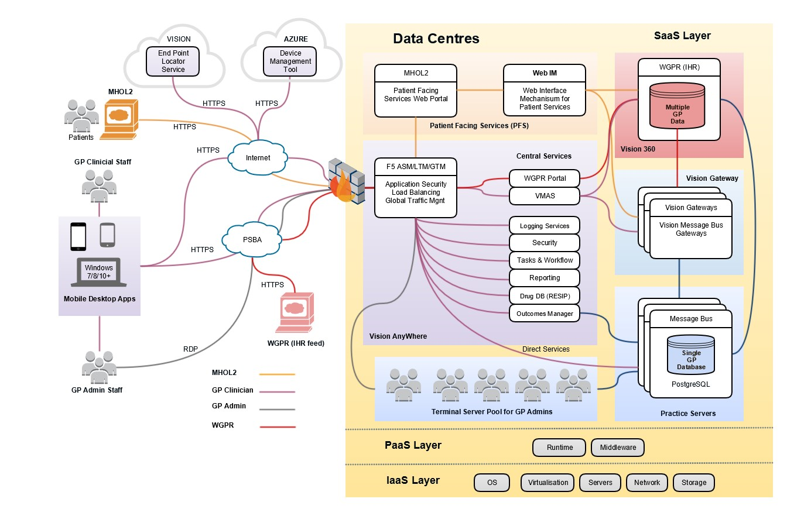

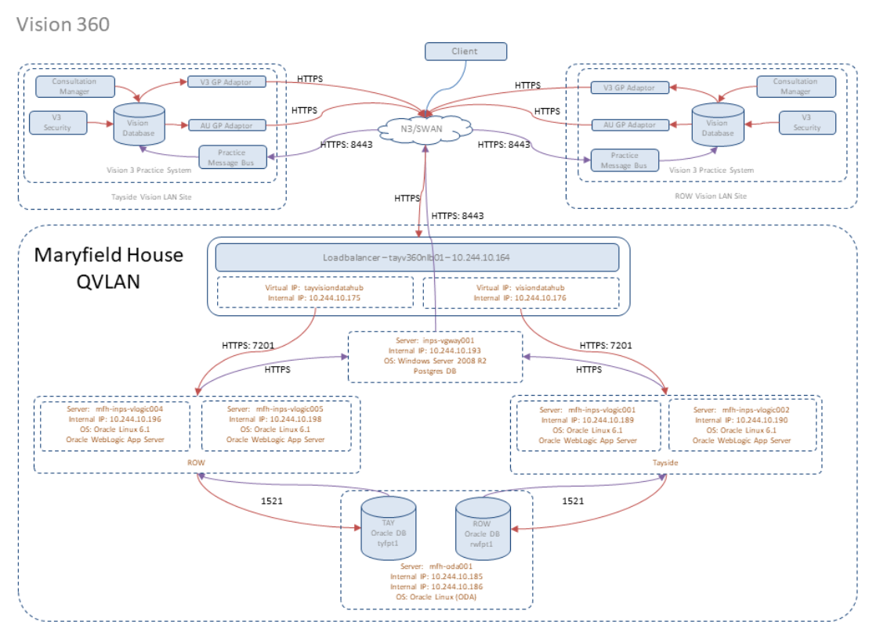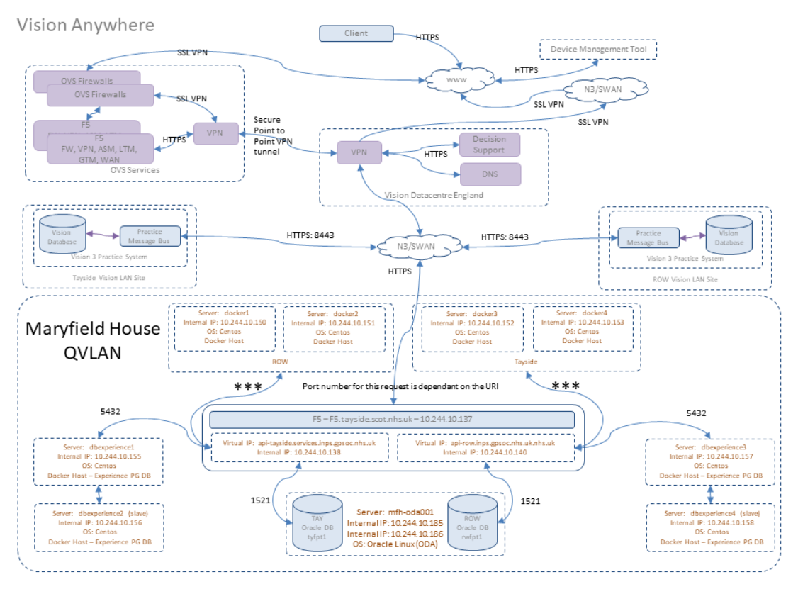
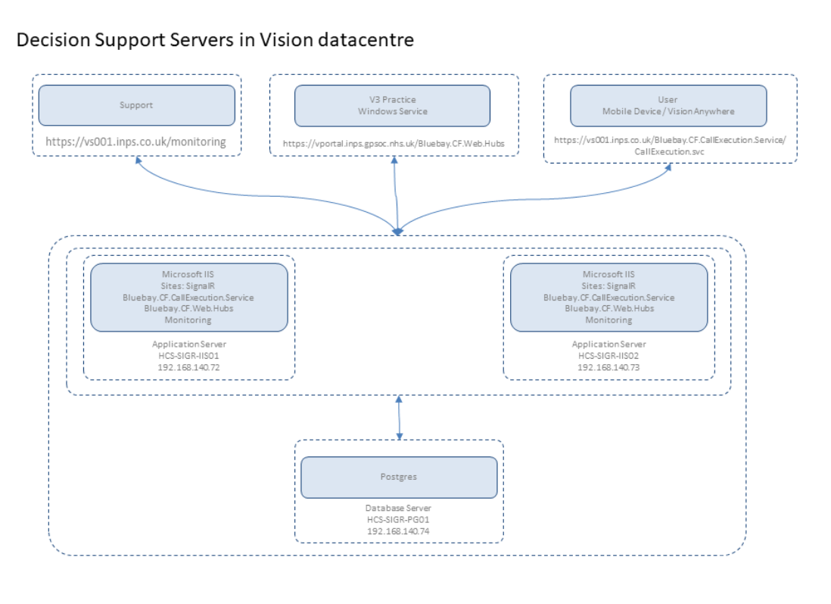

How data/information is to be accessed, processed and used

Processing (descriptor) | Associated work instructions, policy or procedure (listed in Appendix 1) If applicable
Access to the records will be via role based account.  Processing is necessary for medical purposes and will be undertaken by a health professional or a person with a duty of confidentiality.  Patient Identifiable information (Personal Data) is shared in order to allow Data Processor to support patient treatment.  NHS Tayside and the GP Practices are Joint Data Controllers | IT Service Desk Protocol

Summary of how decisions are going to be made with regards to the manner of the processing.
Data controllers will decide jointly on any decisions about the way the data is processed, the security controls (technical or organisational).
4 Impact assessments and preparatory work
A Data Protection Impact Assessment DPIA has been carried out.
Mandatory statement:
The parties acknowledge that any actions and countermeasures agreed as part of the Data Protection Impact Assessment reviews must be implemented by the responsible party. Deadlines and follow up to progress on those actions will be established as part of the DPIA review process.
5 Privacy information (transparency requirement)
Each data controller has a duty to inform their patients how they process their personal identifiable and special category information, the purpose and legal basis for doing this, who the information may be shared with and the reason for sharing this information.
NHS Tayside Privacy Notice
Aberfeldy Medical Practice
Alyth Health Centre
Ardblair Medical Centre
Atholl Medical Centre
Carse Medical Practice
Comrie Medical Centre
Coupar Angus Medical Centre
Craigvinean Surgery
Crieff Health Centre – Blue Practice
Crieff Health Centre – Red Practice
Drumhar Health Centre – Mauve Practice
Drumhar Health Centre – Yellow Practice
Glover Street Medical Centre - Kings Practice
Glover Street Medical Centre - Victoria Practice
Loch Leven Health Centre – Orwell Practice
Loch Leven Health Centre – St Serfs Practice
Perth City Medical Centre
St Margaret’s Health Centre
Stanley Medical Centre
Strathmore Surgery
Taymount Surgery
Whitefriars Surgery – Green Practice
Whitefriars Surgery – Red Practice

GP Practices process personal identifiable information that relates to patients and is therefore required by law to comply with the General Data Protection Regulations (GDPR), which protect patient’s privacy and ensure that personal information is processed fairly and lawfully.

6 Accuracy of the information

6.1 Agreed steps to ensure the accuracy of any data shared.
Where data is shared and data entry is required, users will have appropriate training in use of the system from both the GP and health board perspective. All users will be aware of the importance of accurate data.
All users must complete the mandatory LearnPro Safe Information Handling module.
6.2 Agreed arrangements for any challenges to the accuracy of information
All parties are responsible for ensuring all information, including personal data, is complete, accurate, relevant, accessible and timely.
All parties will ensure all appropriate staff using information shared by another party will take reasonable steps to confirm the accuracy of the information. This will involve confirming the accuracy of the information with the patient where possible.
It is the responsibility of all parties to ensure that their staff know how to respond to the identification of an actual or possible inaccuracy in information. The response to an inaccuracy should be managed by that party following business as usual process.
As controllers, all parties have the responsibility for managing records, rectifying inaccuracies, and communicating updates with all other relevant parties.

7 Data retention and secure disposal

7.1 Retention period and purpose

- Partners to this agreement undertake that information shared under the agreement will only be used for the specific purpose for which it was shared, in line with this agreement. It must not be shared for any other purpose outside of this agreement
- In each case, the originating organisation remains the primary information owner and record keeper for the information that is shared
- Data must be retained in accordance with the Scottish Government Records Management NHS Code of Practice (Scotland) and Records Retention Schedules
The recipient will not release the information to any third party without obtaining the express written NHS Scotland of the partner who provided the information.

7.2 Secure disposal of information

- The following destruction processes will be used when the information is no longer required:

  - Confidentially and securely destroyed in line with local policy and procedure
  - Electronic files will be data cleansed in line with local policies and procedures; During the data cleansing process information held will be audited and deleted if no longer required to maintain EUGDPR compliance8 The rights of individuals
8 The rights of individuals

8.1 Subject Access Requests
Under the General Data Protection Regulation / UK Data Protection Act 2018 a data subject (or authorised individuals acting on their behalf) has the right to make a Subject Access Request and to receive a copy of the personal data relating to them which is processed by an organisation. Dealing with such requests is the responsibility of each individual data controller. Communication must take place speedily to ensure the request is processed within the statutory one-month time period.
8.2 Freedom of Information (Scotland) Act 2002 – Information Requests
All the Parties are Scottish public authorities for purposes of the Freedom of Information (Scotland) Act 2002 and must respond to any request for recorded information made to them in a permanent form (such as letter or email). This would include an obligation to respond to requests about information sharing practices and procedures such as the arrangements under this Protocol. It should be noted that the actual personal information exchanged between the Parties will, in almost every case, itself be exempt from disclosure under the freedom of information legislation.
Any request for information submitted to either organisation will be processed under the organisations existing FOISA handling procedures, passing up through the organisations internal review process where appropriate.
8.3 Objection or restriction to processing, rectification and erasure

- Right to rectification:
Individuals have the right to request rectification of personal information held about them if it is found to be inaccurate.
Policies and procedures are in place. Training delivered to relevant staff. We are aware, and uphold, response timeframes. All cases are treated on a case-by-case basis.
- Right to object (where applicable):
While not an absolute right, an individual has the right to object to the processing. However, all requests would be considered on a case-by-case basis in relation to our compelling reasons in relation to our public task which can be found on the Controller’s Privacy Notice.

- Right to restrict processing (where applicable):
While not an absolute right, an individual has the right to restrict processing and this would be considered on a case-by-case basis in relation to our compelling reasons in relation to our public task which can be found on the Controller’s Privacy Notice.
- Right to data portability (where applicable):
Data portability would not be applicable in this particular situation. The right only applies to information an individual has provided to a controller.
- Right to erasure (where applicable):
When we process personal information, individuals can exercise their right to erasure. This is not an absolute right and we will review each request on a case-by-case basis. It is likely this will be overruled as processing is taking place in line with our public task.
- Rights in relation to automated decision-making and profiling (where applicable):
Automated individual decision-making (making a decision solely by automated means without any human involvement); and profiling (automated processing of personal data to evaluate certain things about an individual). Profiling can be part of an automated decision-making process.

The GDPR applies to all automated individual decision-making and profiling without human intervention, therefore not applicable in this particular situation.

8.4 Direct Marketing
No direct marketing is involved in this agreement.

9 Security, risk and impact of the processing
All relevant Security Policies applicable to the parties and systems used in this proposal are available and listed in Appendix 1.
A qualified Information Security Officer has reviewed the adequacy of the attached Security Policies and has advised on the technical and organisational security risk level.
A suitable process to document and monitor the security risk described in the Information Security and Governance Policies listed in Appendix 1.
A Data Protection Impact assessment has been produced and is available as listed in Appendix 1.
A competent, independent and free of conflicts of interests Data Protection Officer has been designated to inform the Data Controllers on the adequacy of this agreement and the corresponding compliance and any residual risks documented in the Data Protection Impact Assessment.
The security measures put in place across the parties ensure that:
[Y ] Wherever special categories of data are processed, the data will be encrypted at rest and in transit.
[Y ] Wherever special categories of data are transmitted over network, Transport Layer Security (TLS) protocols will be applied. Exceptions will be documented in the DPIA and any residual risk will require approval by the SIRO of each organisation prior to processing such data.
[ Y] only authorised individuals can access, alter, disclose or destroy data. This is achieved through the following work instructions, policies and procedures (also listed in Appendix 1):
[ Y ] authorised individuals act only within the scope of their authority. This is achieved through the following work instructions, policies and procedures (also listed in Appendix 1):
Role based access controls are in place and all staff (NHS Tayside and GP Practice staff) are on and off boarded via NHS Tayside helpdesk, in compliance with NHS Tayside System Access Management policy.
[ Y ] if personal data is accidentally lost, altered or destroyed, it can be recovered to prevent any damage or distress to the individuals concerned. This is achieved through the following work instructions, policies and procedures (also listed in Appendix 1):
Appointments Servers are backed up as per NHS Tayside standard backup process.
Practice Clinical Systems are backed up daily and stored on backup tapes and rotated. A backup tape is stored offsite and verified by engineer support provider.

The security controls applicable by each organisation will be: | Yes | Jointly agreed between the parties
 |  | Independently decided by each party

9.1 Agreed standards, codes of conduct and certifications

- All NHS Tayside Information Governance policies and safe information handling practices including:

  - NHS Tayside Information Security Policy
  - NHS Tayside Data Protection Policy
  - Caldicott
  - Freedom of Information (Scotland) Act
  - System Access Management Policy
  - Data Quality Policy

10 International transfers of personal data
Personal data shared in line with this agreement will be transferred to:

 | EEA countries only
 | Outwith EEA
X | Will not be transferred outside the UK

10.1 List of countries where the data will be transferred to (if applicable).
N/A
10.2 Reasons for transferring personal data outside the UK
N/A
11. Implementation of the information sharing agreement
11.1 Dates when information sharing commences/ends
This Information Sharing Agreement will commence on 10th April 2020
11.2 Training and communications
Training for Data processors will commence after date of signatories below. The system supplier will undertake training both on-site and web based.
11.3 Information sharing instructions and security controls
All relevant information sharing instructions, including but not exclusively any work instructions, policies or procedures, are listed in Appendix 1 and accepted by all parties.
11.4 Non-routine information sharing and exceptional circumstances
All information in the GP record is being shared as part of the Information Sharing Agreement.
11.5 Monitoring, review and continuous improvement
This Information Sharing Agreement will be audited annually or when changes are made to the way data is being processed or collected.

12 Sign-off
"We the undersigned agree to the details recorded in this Information Sharing Agreement; are satisfied that our representatives have carried out the preparatory work set out in the Information Sharing Tool-kit for Scotland and are committed to the ongoing monitoring and review of the scope, purpose and manner of the information sharing."

Name of the Party |  | NHS Tayside Board  Ninewells Hospital and Medical School  Dundee  DD1 9SY
Authorised signatory | Title and name |  | Professor Peter Stonebridge
 | Role |  | Medical Director
Signature and date
Data Protection Officer |  | Alison Dailly
Senior Information Risk Owner |  |  |  | Margaret Dunning

Name of the Party |  | Perth and Kinross GP Practices
Authorised signatory | Title and name |  | Local Medical Committee
 | Role
Signature and date
Data Protection Officer |  | Alison Dailly
Senior Information Risk Owner
The signatory has delegated sign off powers on behalf of:
- Perth and Kinross GP Practices (P5-8)
Parties without delegated sign off powers are required to sign off individually using the Multi Party Sign Off Form included in the toolkit.

13 Appendix 1: List of Work instructions, policies and procedures

Work instructions title | Organisation | Where to find this document (e.g. hyperlink)
Policies described on page 20 | NHS Tayside | NHS Tayside Website or NHS Tayside Staffnet
The above table should list all:
- Instructions for reaching agreement on any changes to the purpose of the sharing.
- All applicable and relevant Information Security and Governance Policies
- All Data Protection Impact assessments

14 Appendix 2: Data items and adequacy
Data Item | Source | Recipients | Data minimisation justification | For data linkage only
Full Medical Record | GP Clinical Systems | NHS Tayside
The above table should contain:
The list of all relevant data items/fields which it has been agreed can be shared under this ISA, indicating the source and the recipients, and any relevant supporting statement for information that may raise questions on data minimisation.

